# CS 255 System Design Document – Project Two

## UML Diagrams

### UML Use Case Diagram

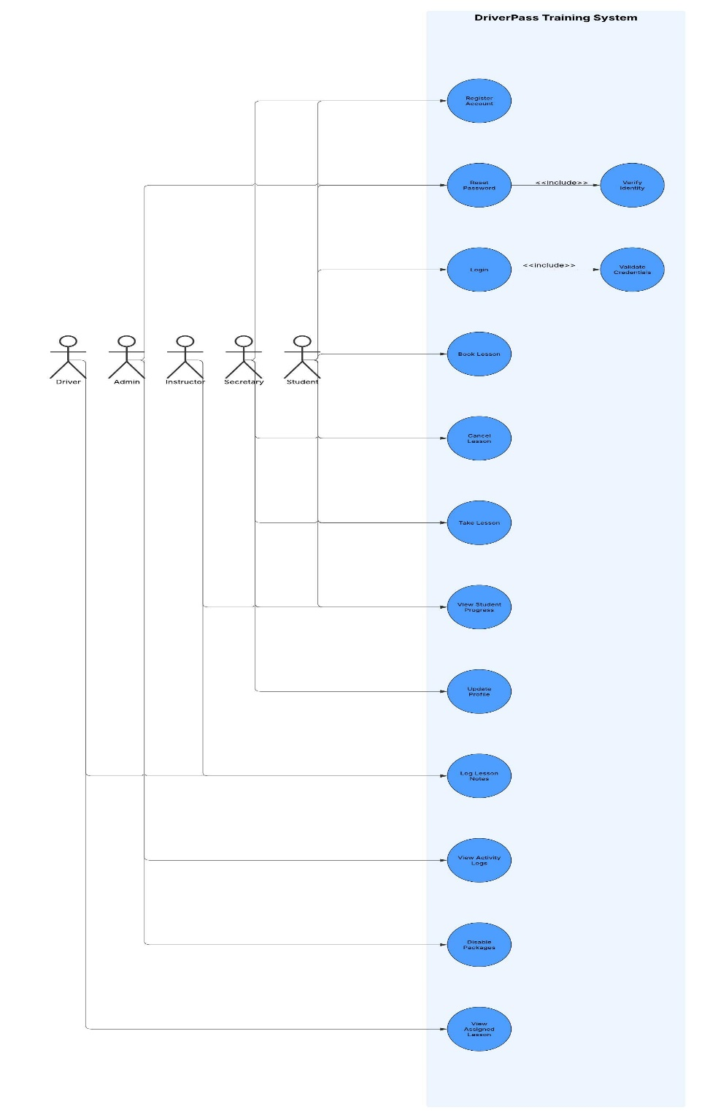

### UML Activity Diagrams

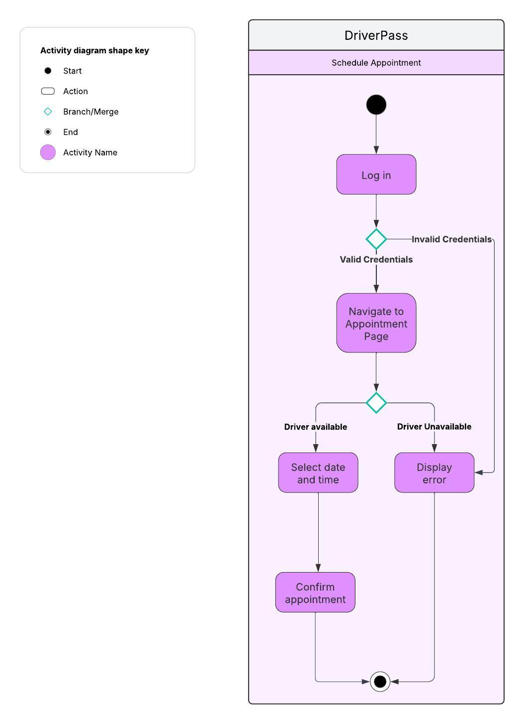

### 

### UML Sequence Diagram

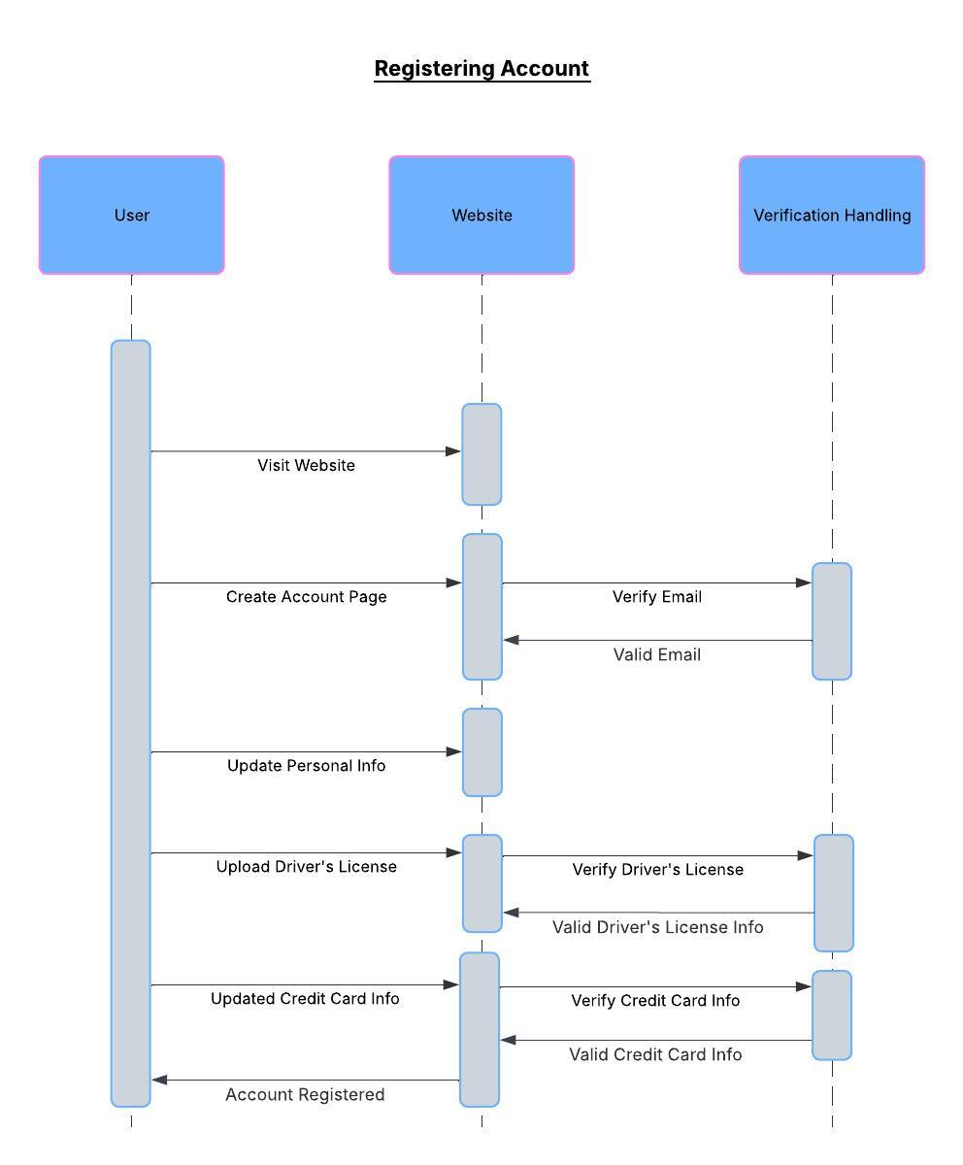

### UML Class Diagram

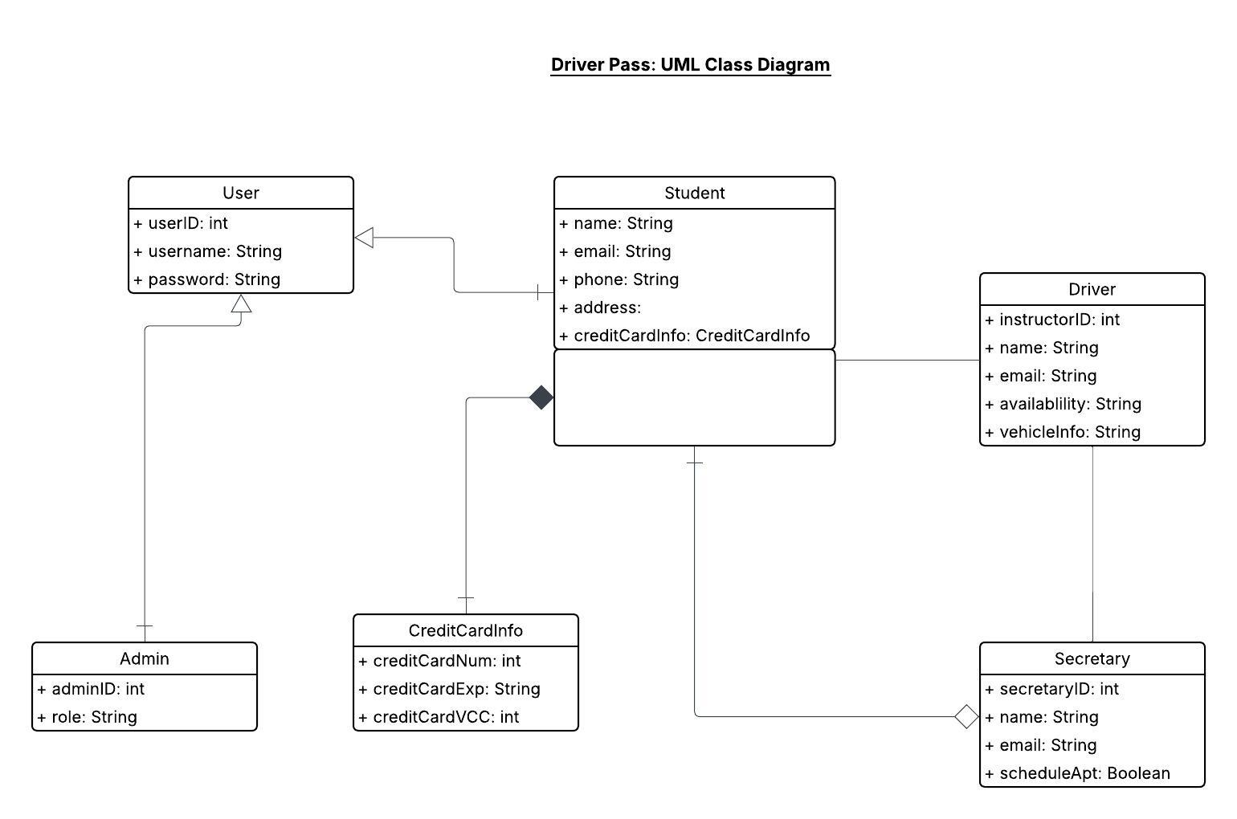

## Technical Requirements

**Hardware:**

* Scalable web server to handle peak traffic during course signups and scheduling
* Secure database server for storing user accounts, driver’s license information, and payment details

**Software:**

* Web application built using standard front-end (HTML/CSS/JavaScript) and back-end technologies (Node.js, Python)
* Secure authentication framework for user login and session handling
* Payment processing API integration

**Tools & Infrastructure:**

* Cloud-based hosting to ensure uptime (Azure)
* SSL certificates for encrypted data transmission
* Verification systems for email, driver’s license, and credit card data